Mini-SAM II
Owner’s Manual for Model MS-2E Rev 1.2

Professional Sound and Motion Controller

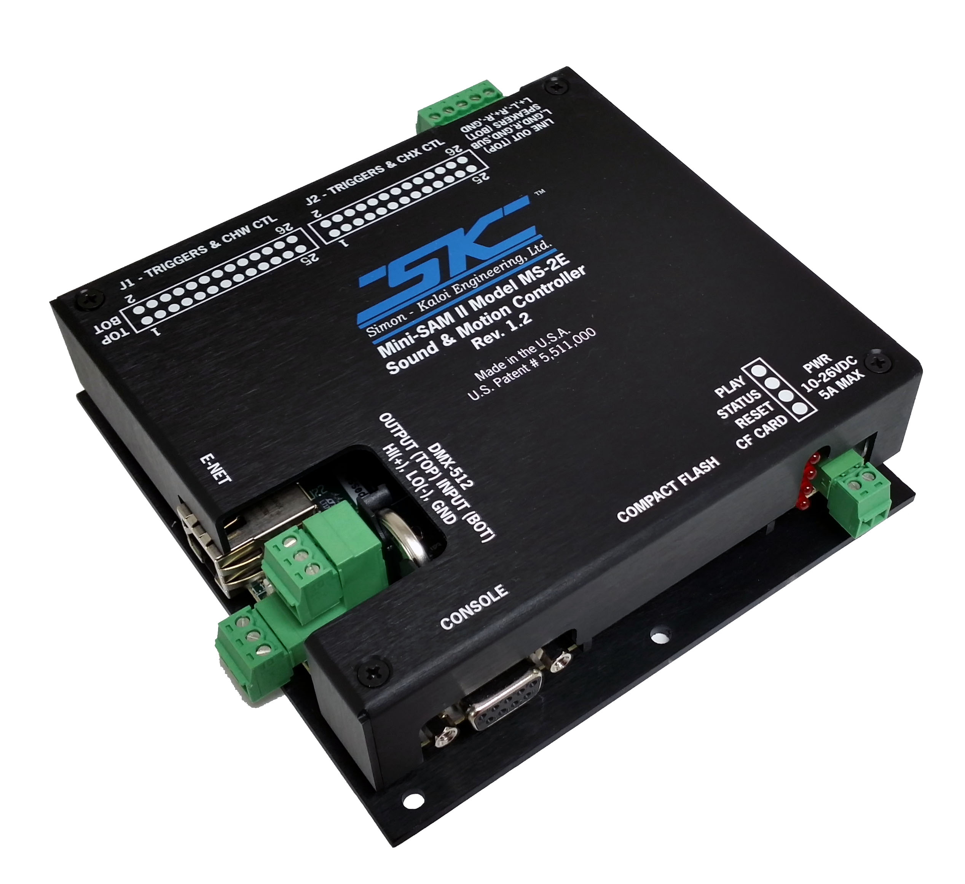

Revision 2.12
February 2020
Authored by D. Kaloi and R. Simon
© 2005-2020 Simon-Kaloi Engineering, Ltd.
Table of Contents
Important Safety Instructions 3
Introduction 4
System Block Diagram 5
Optional Support Hardware and Software 6
Mini-SAM II Layout 7
J1,J2 Input/Output Connector 8
J2 Input/Output Connector 10
Line Output/Speaker Output Connector 10
CODEC Programming I/F 11
Ethernet I/F 11
RESET and RUN/STOP Switches 11
DMX I/F 11
Volume Control Buttons 12
Boot and Function Switches 12
Real-Time Clock Backup Battery 13
Console Serial Port (DCE) 13
Compact Flash Memory Card Interface 13
Status LEDs 13
Power Input Connector 14
External Clock Interface 14
Software 15
Files 15
Sound Files 15
Control Files 15
Programmer 17
Hardware Setup: 17
Channel Configuration: 17
Control Recording: 18
Loading and Saving Control Recording Sessions: 19
Program Editor: 19
DMXEdit 20
Loading a New Operating System 21
Features and Specifications 22
Chassis Mounting Diagram 23
WARRANTY 24
LIMITATION OF LIABILITY 24

Important Safety Instructions

- Always follow basic safety precautions when using this product to reduce risk of injury from fire or electrical shock.

- Read and understand all instructions in the owner’s manual before using this product.

- Observe all warnings and instructions marked on the product.

- Disconnect this product from electrical power source before cleaning. Clean exposed parts with a damp soft cloth. Do not use cleaning agents or aerosols.

- Do not use this product near water or when wet. If this product gets wet, disconnect from power source immediately. Do not reconnect power until the unit has been dried thoroughly.

- This product should be mounted in a rack or placed on stable surface prior to use. Do not use this product if it has been dropped or damaged. Contact manufacturer for service or repair.

- Product should be mounted or placed in a location where cords and cables do not present a hazard.

- Cords and cables should be routed in a manner to prevent damage or abrasion. Use proper strain relief.

- Always make connections and disconnections with power off.

- Use power sources only as marked on the unit, specifically recommended in this manual or as supplied by the manufacturer. Do not overload electrical outlets or extension cords. This may increase risk of fire or electrical shock.

- Do not operate this product in rain, snow or other adverse conditions.

- If this unit does not operate properly, refer to the troubleshooting section of this manual. If the problem cannot be resolved contact the manufacturer for service or repair.

- No user serviceable parts are in this product.

- Removing the cover may cause exposure to dangerous voltages or other risks as well as void the warranty.

Introduction

The Mini-SAM II (model MS-2E), digitally plays back synchronous digital audio and control information. Its compact size and efficient design make it perfect for message repeating and control applications where cost and space are a concern. The MS-2E plays 2.1 channels of digital audio (1 stereo channel with subwoofer or two independent mono channels), along with synchronous control information. A multi-channel polyphony feature allows numerous audio files to play on the same channel(s). Audio and control information are stored on a Compact Flash Card (CF card) that are not included. Files can be efficiently transferred to and from CF cards using a PC with a CF card reader/writer or via a local area network (LAN) and the MS-2E’s Ethernet Port and a FTP file transfer program. The MS-2E plays uncompressed .WAV formatted stereo or mono files with 16 bits of resolution with at a sampling rate of up to 44.1Khz. The hardware is capable of 24 bit audio resolution and up 48Khz sampling rate (with future operational software) however, higher sampling and especially higher bit resolution will reduce performance with certain functions such as the number of tracks that can be played with polyphony. The powerful on-board power amplifier provides 80W x 80W into 4 ohms, 40W x 40W into 8 ohms of rock-solid power. Audio line outs and provisions for line and microphone inputs are also provided. Eight optically isolated trigger inputs, 16 direct output controls, and DMX-512 in/out for additional control are all included. The on-board real-time clock facilitates event triggering.

The Mini-SAM II has on-board Digital Signal Processing (DSP) capability that utilizes the powerful SKE Sequence Programming Language (SPL). The SPL lets the user write simple to complex scripts that tell the MS-2E what to do and when and how to do it. Scripts can be written on PC, Mac, mobile device, or any device that can output a text file format. Programs such as Word and Notepad are just some of the programs that can output this file format. For more on this see the SKE Software Description Manual. It can be downloaded at the www.skeng.com website. There is also audio processing DSP capability including functions such as seven-band EQ, spatial expansion and compression, and crossover filtering.

Programming control information can be achieved via the SPL, with DMX512 console, or with a PC and the free SKE Programmer Software.

The MS-2E can be used in countless applications including robotics, animated characters, “messages on hold”, annunciators, public address systems, on-board ride-car audio, kiosks, and public safety. Playback can be triggered from several sources including motion sensors, switches, logic signals, door and pressure sensors, timed events, and much more. The unique design behind the Mini-SAM II is patented.

WARNING: READ THIS MANUAL THOUROUGHLY BEFORE BEGINNING USE OF THE MINI-SAM II. ALL THE INFORMATION IN THIS MANUAL IS BELIEVED TO BE CORRECT HOWEVER IS SUBJECT TO CHANGE.

System Block Diagram

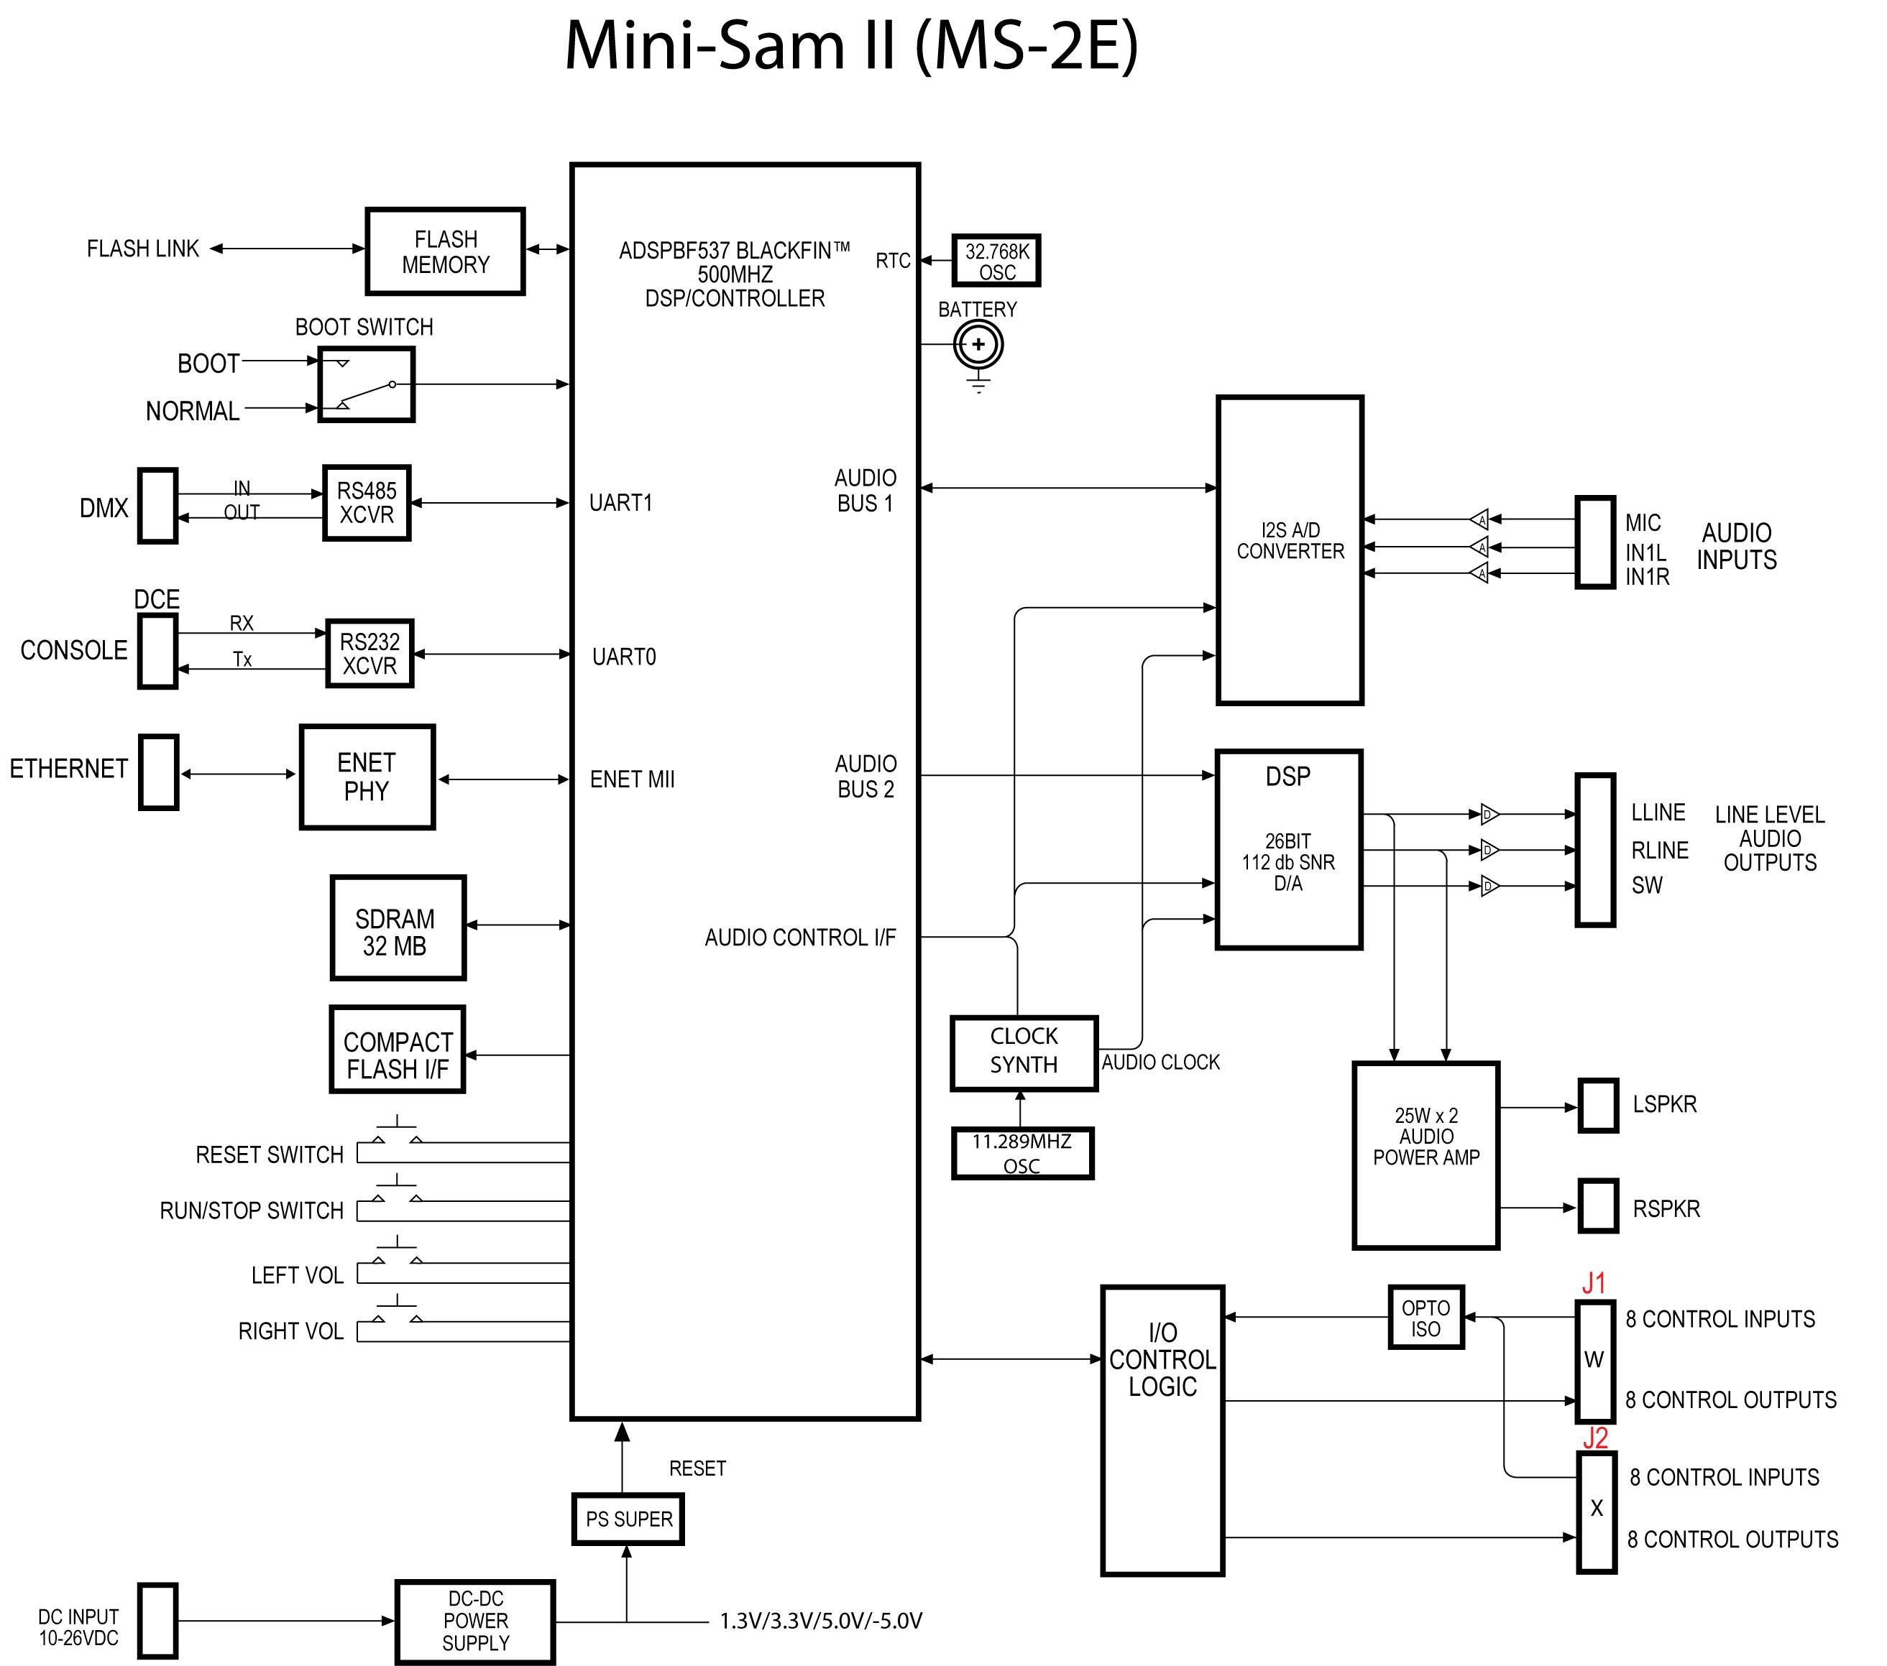

Optional Support Hardware and Software

You can communicate with the MS-2E, issue sequence commands, and receive back diagnostics and other information with a computer (PC, Mac), or other device that can implement a terminal program. There are two ways to communicate with the MS-2E, RS-232 serial or Ethernet. Each is method is addressed below:

RS-232
If you have a computer or device with a built-in RS-232 port, you will need a standard modem style 9-pin female to male serial cable. Connect the female end to the computer and the male to the MS-2E’s Console port. You will also need a terminal program such as Hyperterminal for the PC and CoolTerm for the Mac. You want to directly connect to the computer’s COM port. The default settings for the terminal program should be 115.2Kbps, 1 stop bit, no parity and no hardware handshaking. You will also want to set the terminal to echo characters typed locally and wrap text that exceeds column width. If you do not have a computer or device with a built-in RS-232 port but that does have a USB port, you can use a high-speed USB to RS-232 converter such as the device linked below:

http://www.tripplite.com/EN/products/model.cfm?txtModelID=3914

Once connected, you should see a startup screen similar to the one shown below:

Initializing Ethernet
Initializing DMA
Initializing Interrupts
Enabling DMA
Initializing System Heap space
Launching Sequences
WARNING:No startup sequence found.
=========================================================
Simon-Kaloi Engineering Ltd.MS3e Audio and Control System
Revision 1.75, File:ms3e4475 24OCT2013 44.1K/16bit
=========================================================
DATE: Sat 05/19/23 02:06:48 AM
File System Version: HCC_FAT_LFN ver:2.60
MFG: Fri 11/01/13 12:21:46 PM Serial #1344131040003 F4:1E:26:02:00:3D
IP Address: 169.254.144.60:0 Subnet Mask: 255.255.255.0
a:>

You now should be able to type in commands per the Software Description Manual.

Ethernet
If you have a computer or device with an Ethernet port, you can communicate with the MS-2E’s Ethernet port via an Ethernet cable (either standard or crossover cable will work because the MS-2E will automatically detect it). To load, copy, delete, or change files with either CF card you can simply connect with an FTP Server such as Windows or Internet Explorer on PC, or the FTP address using the GO > Connect To Server Menu on a Mac. You will need the IP address of the MS-2E which can set in the .ini file (with a text editor) on the CF card, or can be viewed in the startup screen when connected via RS-232. The Password default is “SKE”.

To communicate commands and see status on the MS-2E, you will need a UDP terminal program such as Hercules.

Mini-SAM II Layout

A top view of Mini-SAM II Layout is shown below with the cover removed. Removing the four corner screws and then lifting the cover straight off easily accomplishes this. The user interfaces are indicated and a detailed description of each item follows on subsequent pages.

(3) Audio Line Outputs (top)
Speaker Outputs (bottom)

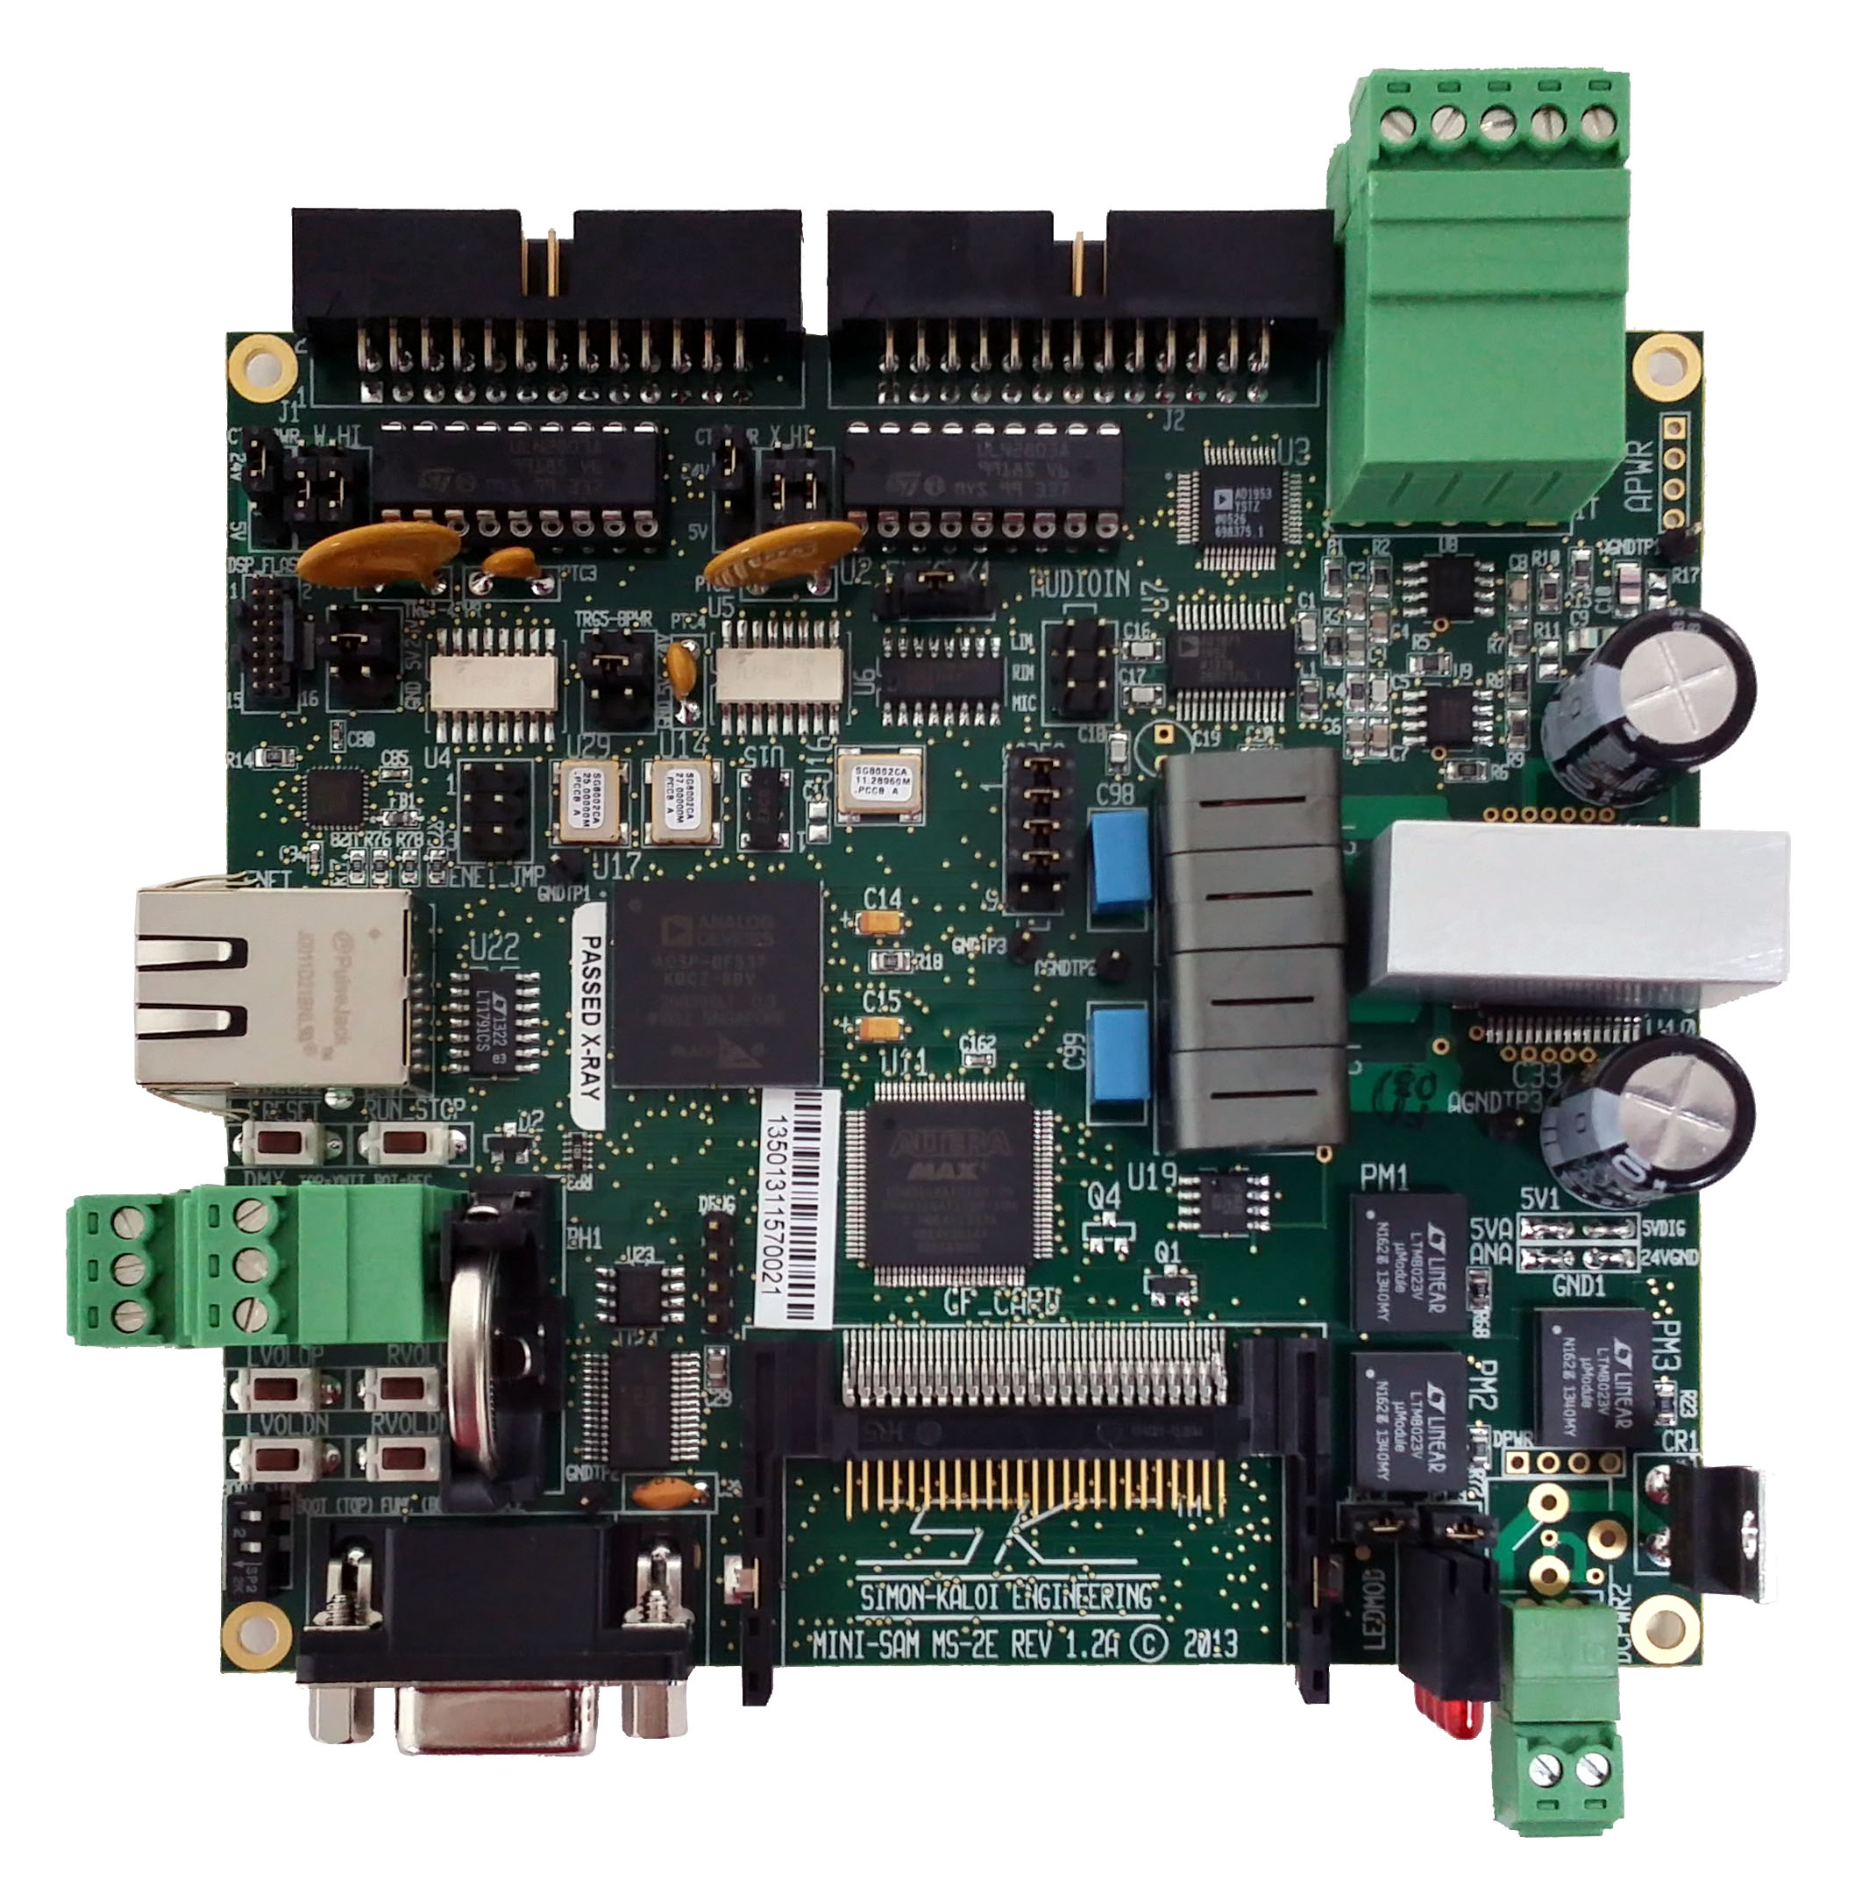
(1) J1 Input/Output Connector
(2) J2 Input/Output Connector
(11) Reset and
Run/Stop Switches
(12) DMX I/F
(13) Volume
Switches
(17) CF Card I/F
(15) Real-Time
Clock Battery
(14) Boot & Function
Switches
(20) Ext Clock I/F

(4) Control W Pwr
Jumpers
(10) Ethernet I/F
(5) Control X Pwr
Jumpers
(6) Trig 1-4 Pwr
Jumpers
(7) Trig 5-8 Pwr
Jumpers

(8) Audio Inputs
(16) RS-232 Console Port
(18) Status LEDs
(19) DC Power Input
(9) CODEC I/F

J1,J2 Input/Output Connector
(1,2) This connector is used for input triggering and Channel W Output control. The connection pin out is provided below. As you face the connector pins, pins 1 and 2 are located the bottom right hand side with pin one on top and two on the bottom. As you move left the top row contains all of the odd number pins (pins 1,3,5…25). As you move left the bottom row contains all of the odd number pins (pins 2,4,6…26).

J1 Pin | Name | Function
1 | CTLWPWR | CHW Control Power
2 | CTLWPWR | CHW Control Power
3 | WOUT1 | CHW Control Output 1
4 | TRIGGER1 | Trigger Input 1
5 | WOUT2 | CHW Control Output 2
6 | TRIGGER2 | Trigger Input 2
7 | WOUT3 | CHW Control Output 3
8 | TRIGGER3 | Trigger Input 3
9 | WOUT4 | CHW Control Output 4
10 | GND | Digital Ground
11 | WOUT5 | CHW Control Output 5
12 | TRIGGER5 | Trigger Input 5
13 | WOUT6 | CHW Control Output 6
14 | TRIGGER6 | Trigger Input 6
15 | WOUT7 | CHW Control Output 7
16 | TRIGGER7 | Trigger Input 7
17 | WOUT8 | CHW Control Output 8
18 | TRIGGER8 | Trigger Input 8
19 | 24VGND | Control Output Ground
20 | GND | Digital Ground
21 | 24VGND | Control Output Ground
22 | TRG1-4PWR | Input Trigger 1-4 Power
23 | TRIGGER4 | Trigger Input 4
24 | CTLWPWR | CHW Control Power
25 | CTLWPWR | CHW Control Power
26 | TRG1-4PWR | Input Trigger 1-4 Power

Trigger Inputs: The following is a circuit diagram of Trigger. The circuits in RED are common to all triggers:

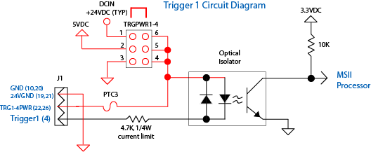

Trigger Inputs can be set via jumper for high or low or isolated high or low side triggering. Each input has a series limiting resistor of 4.7KΩ 1/4W and the typical isolator diode Vf = 1.15V. The current in the diode is then:
Idiode (mA) = (Vpullup – 1.15)/4.7

This current must always be set for between 1 to 5mA. The Trig1-4PWR (6) Jumper sets the mode. With no jumper installed an external isolated power source (recommend 5 to 24VDC) can be connected on pin 22 and/or 26 for isolated low side triggering. Then drive the individual trigger (1-4) with a ground driven signal. This can be an open-collector or drain transistor, relay, switch, etc. With no jumper installed for isolated high side triggering, connect pin 22 and/or 26 to the isolated ground of the triggering source. Then drive the individual trigger (1-4) with a 5 to 24V signal from that isolated source. For convenience you can also trigger the Mini-SAM II without isolation and use the Mini-SAM’s internal power and or ground via the Trig1-4PWR Jumper. Connecting horizontally to the 24V or 5V provides that voltage as the internal high side voltage so that you can externally pull each trigger (1-4) to ground for low-side triggering. Connecting horizontally to the GND provides ground voltage so that you can externally drive each trigger (1-4) high (recommended 5V to 24V) for high-side triggering. This same logic applies to the The Trig5-8PWR (7).

Control Outputs: The following is a circuit diagram of CHW Control Output 1. The same logic applies to the CHX circuitry. The circuits in RED are common to all outputs:

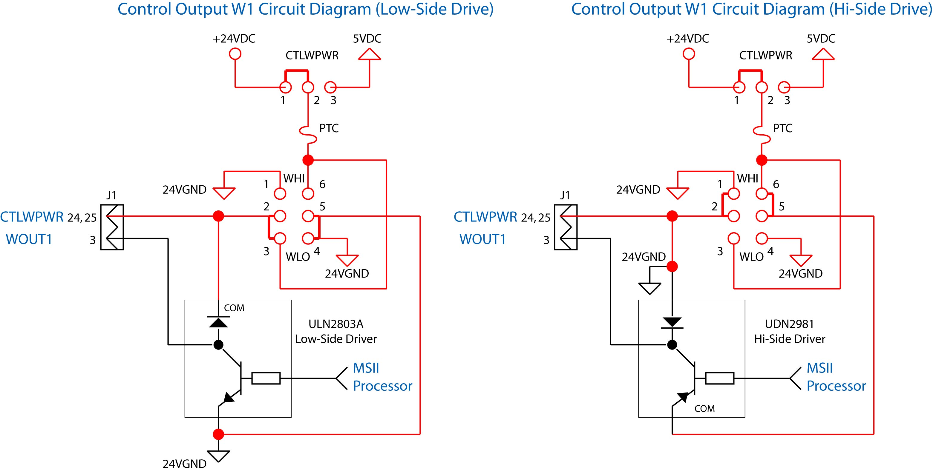
MIC2981/82YN
Hi-Side Driver

In the standard configuration, control outputs are open-collector low-side drivers capable of 200mA (typical) sink current. Higher currents at lower duty cycles are possible so long as maximum current and power specifications of the ULN2803 driver are not exceeded (consult the Allegro ULN2803 datasheet). You can use the CTLWPWR (4) jumper to select from the MS-2E 24V power or 5V power, or provide your own power by removing the CTLWPWR jumper and providing external power to the common signal. Jumper from the center pin to the 24V pin for 24V relays, valves and other loads, or 5V for 5V loads (maximum total current of 1.3A). Note that the 24V setting for all jumpers is actually the DC input power voltage. Therefore if another e.g., 12V power source is used, that will be the voltage at the 24V jumper positions. In the standard low-side drive mode the WLO jumpers are set as shown above. If it is desired to implement high-side drive, with power removed, U1 and U2 must be changed to MIC2981/82YN integrated circuits and the jumpers must be moved from the WLO to WHI (4) setting as shown above. The jumper positions for power and hi/low side drive apply to all eight bits of the corresponding channel, e.g., CHW for all eight bits of CHW.

IMPORTANT: FOR INDUCTIVE LOADS SUCH AS SOLENOIDS, ALWAYS MAKE SURE THE LOAD HAS FLYBACK DIODE MOUNTED AT OR IN THE LOAD TO PREVENT INDUCTIVE KICK DAMAGE TO THE LOAD AND MS-2E DRIVER CHIPS. NEVER SHORT ANY CONTOL OUTPUT DIRECTLY TO GROUND AS THIS WILL MOST LIKELY DAMAGE THE DRIVER.

J2 Input/Output Connector
(2) This connector is used for input triggering and Channel X Output control. The connection pin out is provided below. As you face the connector pins, pins 1 and 2 are located the bottom right hand side with pin one on top and two on the bottom. As you move left the top row contains all of the odd number pins (pins 1,3,5…25). As you move left the bottom row contains all of the odd number pins (pins 2,4,6…26).

J2 Pin | Name | Function
1 | CTLXPWR | CHX Control Power
2 | CTLXPWR | CHX Control Power
3 | XOUT1 | CHX Control Output 1
4 | TRIGGER1 | Trigger Input 1
5 | XOUT2 | CHX Control Output 2
6 | TRIGGER2 | Trigger Input 2
7 | XOUT3 | CHX Control Output 3
8 | TRIGGER3 | Trigger Input 3
9 | XOUT4 | CHX Control Output 4
10 | GND | Digital Ground
11 | XOUT5 | CHX Control Output 5
12 | TRIGGER5 | Trigger Input 5
13 | XOUT6 | CHX Control Output 6
14 | TRIGGER6 | Trigger Input 6
15 | XOUT7 | CHX Control Output 7
16 | TRIGGER7 | Trigger Input 7
17 | XOUT8 | CHX Control Output 8
18 | TRIGGER8 | Trigger Input 8
19 | 24VGND | Control Output Ground
20 | GND | Digital Ground
21 | 24VGND | Control Output Ground
22 | TRG5-8PWR | Input Trigger 5-8 Power
23 | TRIGGER4 | Trigger Input 4
24 | CTLXPWR | CHX Control Power
25 | CTLXPWR | CHX Control Power
26 | TRG5-8PWR | Input Trigger 5-8 Power

See J1 for triggering and control configurations (same logic applies). CTLXPWR and XHI, XLO (5) jumpers set configuration similar to CHW.

Line Output/Speaker Output Connector
(3) As you face the connector (pin 1 is on the left) the left, right, and subwoofer line outputs are on the top connector and the speakers outputs are on the bottom. The connections should be made as follows:

 | Terminal 1 | Terminal 2 | Terminal 3 | Terminal 4 | Terminal 5
Top Row | Left Line Out | Gnd | Right Line Out | Gnd | SW Line Out
Bottom Row | Left Speaker + | Left Speaker - | Right Speaker + | Right Speaker - | Gnd

SW stands for Subwoofer. All audio line outputs are unbalanced with typical output level of -10dB. You can connect these signals to an audio power amplifier.

The speaker outputs provide a high-powered amplified output for driving speakers. For each output the overall load should be ≥ 4 Ω. For cases where additional current drive is desired you can play the same information on both left and right channels and parallel the outputs.

IMPORTANT: WHEN CONNECTING THE SPEAKERS IT IS CRITICAL TO CONNECT WITH PROPER PHASING. CONNECT THE SPEAKER’S “+” TERMINIAL TO THE TOP TERMINAL OF AND THE SPEAKER’S “-” TERMINAL TO THE BOTTOM TERMINAL FOR BOTH THE LEFT (TOP) AND RIGHT (BOTTOM) CONNECTORS OF THE MS-2E. FOR PARALLELING OUTPUTS, CONNECT LSPKR “+” to RSPKR “+” AND LSPKR “-” to RSPKR “-”. DO NOT CONNECT ANY SPEAKER CONNECTIONS TO GROUND AS BOTH SPEAKER OUTPUTS HAVE DC AND OPPOSITE PHASE VOLTAGES (BTL CONFIGURATION) AND THEREFORE SHOULD REMAIN FLOATING FROM GROUND.
Audio Input Connector
(8) This 0.1” on center, six pin male header style connector allows unbalanced left and right audio line level sources (typically -10dB) as well as a microphone to be connected to the Mini-SAM II. The LIN should be connected to the signal wire of a CD or other audio line level source and the GND to the right connected to the shield. The same connection scheme should be applied for the RIN and GND connections. The MIC input allows an unbalanced microphone to be connected (signal) and GND to be used with the MS-2E. These audio sources route to an Analog to Digital Converter and allow features such as recording, public address, audio mixing, and several other functions. Connection wires should exit the MS-2E near the audio line out connector as shown in the picture above.

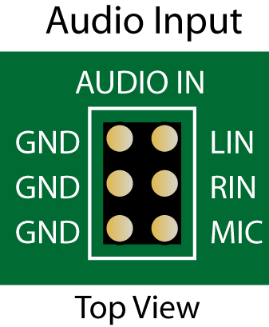

CODEC Programming I/F
(9) This alternate interface allows direct connection to the audio CODEC with Analog Devices programming tools. Consult SKE directly for more information.

Ethernet I/F
(10) The MS-2E has a full Ethernet Interface. The functionality of this interface has not been implemented in software at the time that this manual was written. Look for future software versions of Mini-SAM II OS that will implement the Ethernet interface.

RESET and RUN/STOP Switches
(11) The left switch is a Reset Switch that resets the Mini-SAM II. This switch does essentially the same function as powering down and powering up the unit. Wait about 7 seconds after pressing reset before doing any functions. The right switch is the Run/Stop switch and when will alternately toggle the Run and Stop mode. By default, the unit powers on in the run mode unless this button is held through power up (approximately 7 seconds). When the unit is stopped, all audio, control, and sequence playback is halted. Run mode causes all audio loops and sequences to start up. This switch can also be used to toggle Run/Stop modes as well as implement special functions.

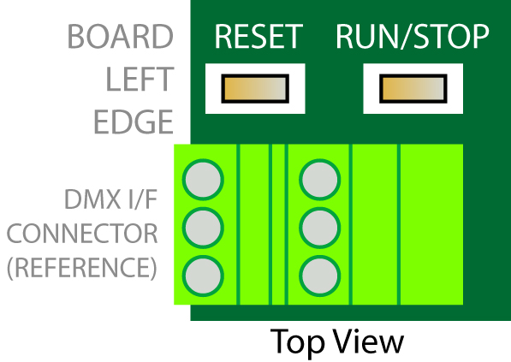

DMX I/F
(12) The Mini-SAM II has a full DMX-512 interface. DMX-512 is an RS-485 (serial communication) lighting standard. The Mini-SAM II uses this standard for not only lighting, but also control expansion (as is used in character animation control), and for optional communication between Mini-SAMs. The top three pins of this connector are for the differential transmitter. Referring to the picture of the MS-2E circuit board, pin 1 is located toward the top of the page. Pin 1 is Tx+, Pin 2 is Tx-, and Pin 3 is Ground. The balanced output impedance of the transmitter is typically 100 ohms. When connecting to DMX equipment, use a controlled impedance cable of 100 ohms (maximum of 120 ohms). You can daisy chain multiple units of DMX equipment (connecting in parallel) however, at the end of the chain a 1/2W 100 ohm (or 120 ohm for 120 ohm cable) should be placed across the “+” and “–” terminals of the last device. For converting DMX data into 16-bits of discrete control over two DMX channels for applications such as animatronic control, the SKE Model DMX16-DO is recommended. The lower portion of the MS-2E’s DMX connector is the differential receiver. Pin 1 is Rx+, Pin 2 is Rx-, and Pin 3 is Ground. This interface can be used to program DMX information into the MS-2E as well as for optional communications between Mini-SAMs.

DMX Pin | Function | Detail
1T | DMX TX+ | RS-485 Output TX+
2T | DMX TX- | RS-485 Output TX-
3T | GROUND | Signal Ground
1B | DMX RX + | RS-485 Input RX+
2B | DMX RX - | RS-485 Input RX-
3B | GROUND | Signal Ground

Volume Control Buttons
(13) Pressing the left top button increases the left channel audio volume. Pressing the right top button increases the left channel audio volume. Pressing the left bottom button decreases the right channel audio volume. Pressing the right bottom button increases the right channel audio volume. The volume changes will be recorded to the resident CF card in the file “ms2.ini” when approximately 4 seconds of inactivity has occurred and restored when the unit is subsequently powered on. This file may be edited to adjust the “power on” volume settings (See the Software Description Manul:Cvol command for reference). The volume settings can also be set from within a sequence and they will override the startup settings until the next time the unit is powered on.

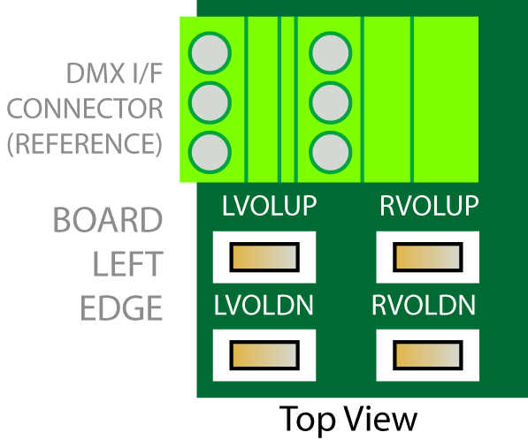

Boot and Function Switches
(14) The Mini-SAM II has the ability to change and upgrade it’s operational software. This is somewhat analogous to a computer upgrading its operating system software. The BOOT switch is the top switch of the BOOT_FUNC switch combo. This switch should be set to right for normal operation. You can install new software with the boot switch in the Normal mode. If there is a problem during an Install e.g., power goes out during the install, you can put the MS-2E into a special Boot mode to enter an backup method for installing. See the Installing New Software Section for more information. The FUNC switch is reserved for future features.

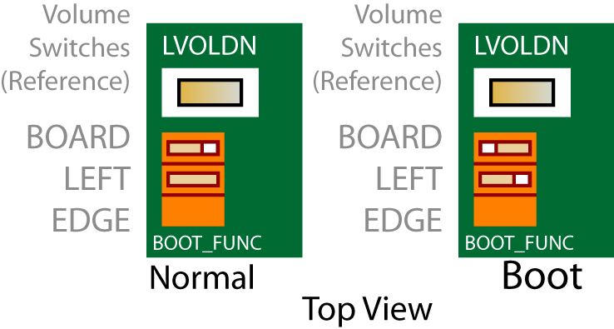

Real-Time Clock Backup Battery
(15) The Mini-SAM II has a real-time clock circuit that keeps track of the actual time. This is useful for example when timed event triggering is desired. The MS-2E uses a 3 Volt 2032 style backup battery to maintain the clock when power is removed. This battery has a long life and can last several years. The battery is only used when MS-2E is not powered therefore the battery life can vary depending on powered use. When this battery measures less than 2.7 Volts it should be replaced.

Console Serial Port (DCE)
(16) The Console interface is a standard 9-PIN Sub-miniature female connector located at the front left edge of the board. The interface is an RS-232 Serial Port providing a DCE style COM port. This port provides for MS-2E control, configuration, status and sequence program initiation. Its primary function is as a command and programming interface. This port has no provisions for hardware handshaking. It can be connected to a standard PC and controlled using a standard terminal program such as HyperTerminal. The default port configuration is 115 kbaud, 8 bits, 1 stop bit, no parity, no handshaking. The port configuration can be changed through the command interface or sequence programming using the Config Console command.

DCE Pin | Function | Detail | Software Channel
1 | DTR | NON CONNECTED | -
2 | TXD | ACTIVE PIN | Console
3 | RXD | ACTIVE PIN | Console
4 | CD | NON CONNECTED | -
5 | GROUND | ACTIVE PIN | Console
6 | N/C | - | -
7 | N/C | - | -
8 | N/C | - | -
9 | RI | NON CONNECTED | -
CASE | CHASSIS GROUND | ACTIVE PIN | Console

Compact Flash Memory Card Interface
(17) The Mini-SAM II uses compact flash memory to store and stream audio and control data. Compact flash is the fastest available solid-state media available and therefore allows the MS-2E to exhibit features and functionality that put it in a class by itself. This interface allows compact flash cards (not provided) of various sizes to be used wit the MS-2E. By using a standard PC and card writer, files can be dragged and dropped as well as removed from the CF card. The card should be sized for the maximum number of files required. For 16-bit 44.1Khz mono files about 5MB per minute of total audio is required (10MB for stereo files). High-performance cards such as the Extreme III by Sandisk are recommended for optimum performance.

The MS-2E will function without a card installed. Cards may be inserted and removed with or without power applied provided there is no write activity in progress. Cards installed in the MS-2E are referenced in software as the “a” drive. The CF IN status LED will illuminate when a card is installed and will blink when the slot is vacant.

Status LEDs
(18) The top LED illuminates when sounds or control files are playing. The second LED from the top illuminates when the MS-2E is in stop (as opposed to run) mode. The third LED from the top illuminates during reset. The bottom LED illuminates when a CF card is present.

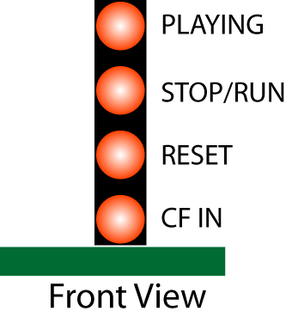

Power Input Connector
(19) The new standard power connector is a two-pin euro-style connector. Connect a 10-24 Volt minimum 2 Amp regulated power supply to this DCPWR2 connector. As you face the connector, the left terminal is designated as the positive power and the right terminal as the power return (gnd). For older legacy MS-E units a 2.1mm connector with tip positive, ring negative (power return/gnd) was used. The Simon-Kaloi Engineering PS-24V Power Supply is recommended for the MS-2E. The power supply should be sized larger for larger loads. For example, if you require 2 amps for the total control loads or want to drive higher audio power, use a minimum 4 Amp supply.

MS-2E Legacy 2.1mm Power Connector

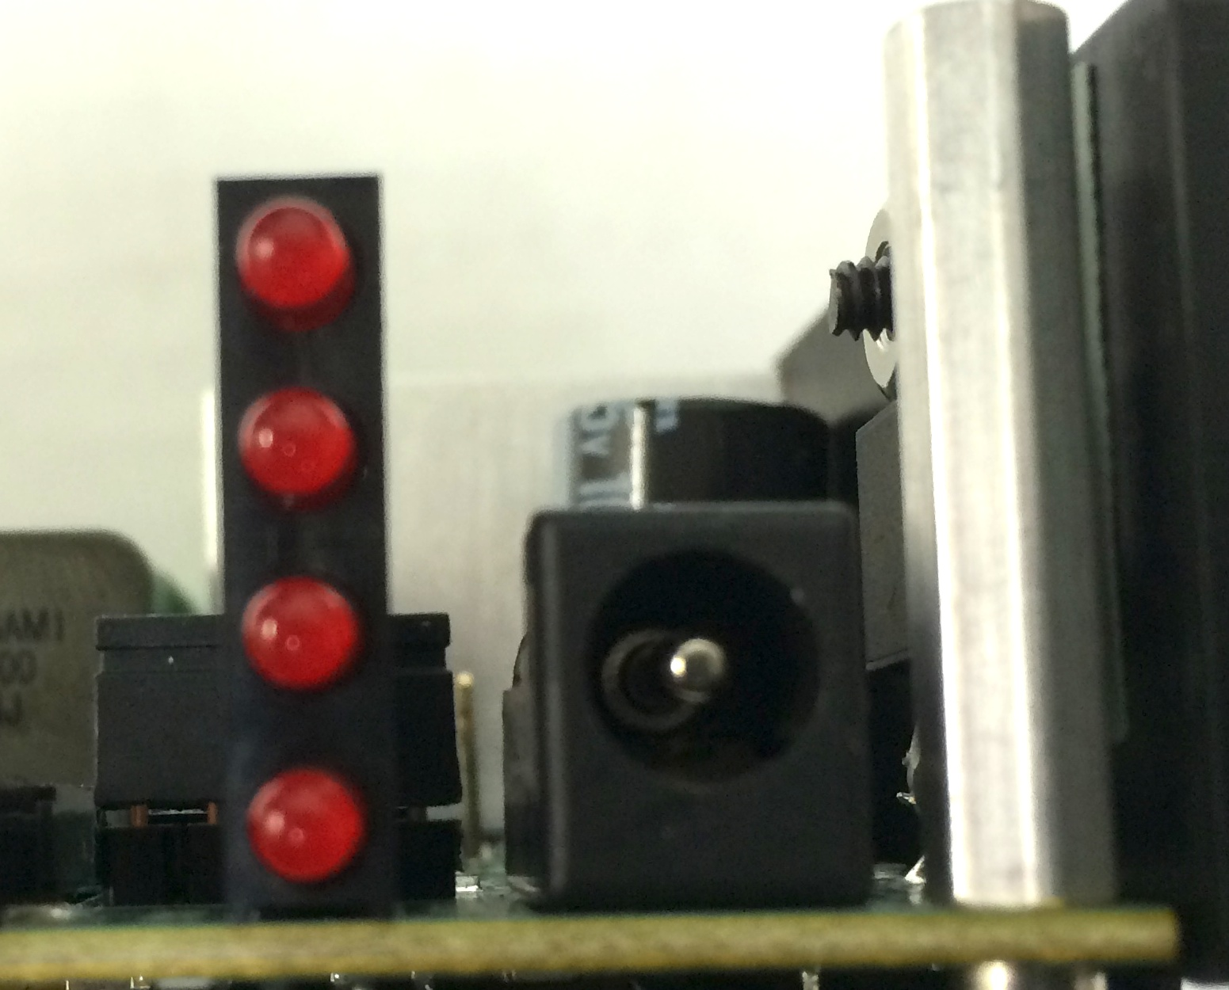

External Clock Interface
(20) The clock interface that is used for clocking the CODEC is available through this interface. Normally the MS-2Es internal clock source is connected to the input of the CODEC via a shunt between pins 2 and 3 of this interface. Sometimes it is desirable to slave multiple MS-2Es from a master MS-2E or rPOD-8.4 so that the audio clocks are in perfect sync and frame accurate. A special daughterboard must connect to this interface in lieu of the shunt for this to occur. Contact SKE directly for more information.

Software
This section covers some of the basic concepts and fundamentals for using the MS-II software and programming system. For more information on programming, refer to the “Software Description Manual rxx.doc” manual.

Files
The MS-II adheres to the FAT32 file system that is recognized by Windows and Macintosh Computers. For best performance high-quality Compact Flash cards such as the Extreme III and Extreme IV series from Sandisk are highly recommened. To load files onto a compact flash card you will need a computer with an internal or external compact flash drive. Simply insert the card into the drive and you should be able to view, add, move, and delete files by dragging and dropping as you would with any other drive. Once your CD card has the desired files, remove the card from the computer drive and insert it into the MS-II for use. There are four types of files that are recognized by the MS-II. Each of these is described below.

- Sound Files – These files are the audio message and music files.
- Control Files – These are the DMX output control files.
- Configuration Files – A set of application, mapping, and parameter files that are used to define the configuration of the two slave Digital Signal Processors (DSP1 and DSP2) for audio output channels 1 – 4 and the subwoofer channels 11 and 12. This includes the settings for equalization, crossover filtering, dynamics and spatial processing.
- Sequence Program Files – These programs are small text files that adhere to the Sequence programming language and provide full customization of the MS-II for your applications. The language turns the MS-II into a full-featured programmable logic controller that allows for advanced triggering, branching, logic, timers, and serial communication control.

Sound Files

The MS-II uses standard RIFF WAVE formatted sound files. Files names and must have a “.wav” extension. The MS-II handles most all internal data with either 28 or 32 bit precision and is capable of processing up to 24bit/48Khz data. Currently, the standard MS-II software accepts only 16bit PCM WAVE files sampled at either 44.1 or 48 Khz. The WAVE files can be either signed mono or stereo files. Consult SKE for more information on the preperation, creation, or conversion of sound files for your application.

There are two methods for playing back sound files on the MS-II:

The first one is the stereo method using the “Play” command. When using this mode, files are played on stereo pairs. These pairs are channels 1 and 2 for the MS-II. When playing stereo files, left data is routed to the first channel in the pair and right data to the second channel. Mono file data is played on both channels of the pair.

The second one is monoral using the “Playm” command. Files are only played back on the channel specified. If a stereo file is used, only the left data is routed to the channel specified and the right data is ignored.

Control Files
Control files are created and managed using the software programming tools developed be SKE. These include the “Programmer”, “DMXEdit”, and the built-in DMX capture commands “Ldrecdmx” and “Recdmx”. A description for using the “Programmer” and “DMXEdit” software is provided later on in this manual. The DMX capture commands are described in the “rPod and MS-II Software Description Manual”.

Control files that were created for use with the rPod, SLAM 8M and first generation MS-II are fully compatible with the MS-II and may be used without any conversion or upgrade. Control file names, like sound file names, must have a “.wav” extension.

A single file can contain one or more embedded channels of data. The MS-II uses a fixed DMX frame of 30 Frames/second with up to 63 channels.

Programmer
The Programmer is a tool for creating and editing control files. It is primarily intended for discrete control programming e.g., character animation.

Hardware Setup:
Make sure that there is a connection between the PCs serial port and the MS-II’s console port using a standard 9-pin male to 9-pin female serial cable. Launch the SKE Programmer and select the appropriate Serial Port. Connect all output control cables and control hardware to the MS-2E and then power up the system.

Channel Configuration:
The diagram below describes the Programmer interface controls.

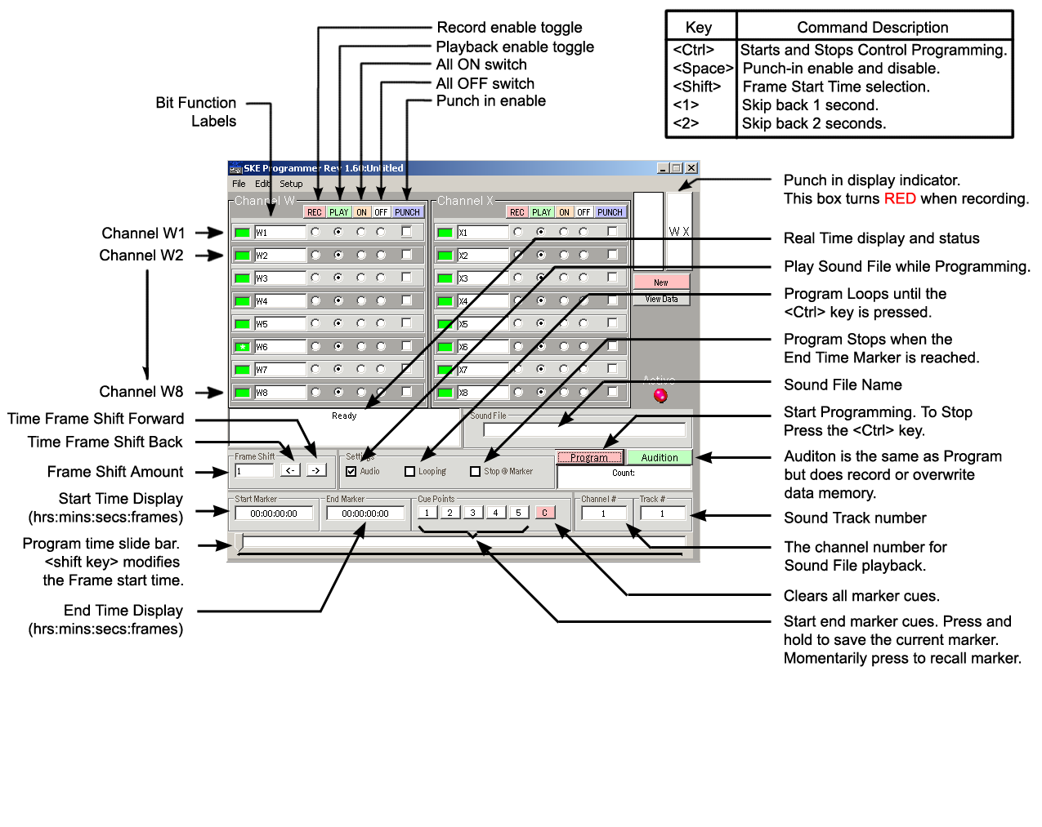
First, select the MS-II Setting in the Programmer setup menu.

You can work with up to two 8-bit Channels (CHW and CHX). When programming, the address for W and X are DMX channels 1and 2 respectively.

The Programmer records four eight-bit channels in groups of two channels. The large WX button toggles between the WX and YZ Channel groups.

For each bit there are four option radio buttons:
- REC – Sets this bit to the record mode.
- PLAY – Sets this bit to the playback mode.
- ON – Turns the bit on (active low). Useful for manual testing of the control bit.
- OFF – Turns the bit off (active high).

Next, select the mode radio buttons, for each bit of the two channels. You can use the buttons above each category to select the mode for all 8 bits of the entire channel.

If programming will be synchronized with audio then select the “Audio” checkbox. Otherwise, un-check this box. To set the audio message that will be played during control programming, type the sound file name into the “sound file” textbox and the audio channel number into the “Ch#” text box. For the MS-II, this can be any channel from 1-10.

Either the keyboard or Joystick may be used to toggles the control bits. The default keyboard to bit assignment is shown in the following table.

Channel W  Bit Number | Keyboard  Assignment | Channel X  Bit Number | Keyboard  Assignment
1  2  3  4  5  6  7  8 | A  S  D  F  J  K  L  ; | 1  2  3  4  5  6  7  8 | Q  W  E  R  U  I  O  P

The assignments may be changed using the assign key map window. This window is opened by selecting “Assign Key Map..” in the “Edit” menu.

Finally, The “PUNCH” checkbox configures the bit for punch-in record mode. After control programming has started, use the <Shift> key to toggle between Play (punch out) and Record (punch in) modes. After recording has stopped, either by hitting the <Ctrl> key or when the end of the sound file is reached, all punch-in channels will be set to the Play mode.

Control Recording:
To begin a control record, either click on the program button or press the computer keyboard <CTRL> key. This key starts and stops the process.

When you are in the process of a control record, the number of frames is displayed in the status window. You can edit the control information any number of times before saving your file.

NOTE: If you hear blips in the audio while performing the control recording, do not worry. This is most likely due to the slower computer’s (generally under 400MHz), inability to keep up with the communication rate. When you playback your final program however, you will see that the audio is clean.

You can also use the slider bar to set a start and end point (use the mouse and SHIFT key to select the range). This allows you to control record small segments without having to playback the entire message. You can also type the frame value into the “Start Marker” and “End Marker” boxes. Selecting the “Stop @ Marker” checkbox will cause programming to automatically stop at the end marker. Selecting the “Looping” checkbox will continuously loop the selected range until programming is stopped using the <Ctrl>key.

A “Frame Shift” function shifts the selected range and control bits that have the “Punch” check box selected. Type the number of frames to shift in the shift frame text box. Then select the “<-“button to shift back in time or the “->”button to shift forward in time the prescribed number of frames.

The “1” and “2” keys can be used to skip back either 1 second or 2 seconds during the control programming process. This is useful for correcting, on the fly, the control program.

Loading and Saving Control Recording Sessions:
You can SAVE and LOAD files to the PC using the “Configure Channels” window. Selecting “Load/Save/Configure” in the “File” menu opens this window. When you are satisfied with the control program for a given channel, save the session by first entering the channel name in the “Channel n Name” text box. Repeat this process for additional channels. To load an existing control program, select the “Load” button and choose the desired file from the open dialog box.

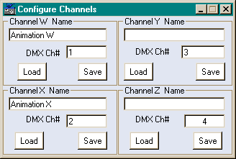

Program Editor:
The Programmer also features a simple editor that allows control data frame data to be edited. To access this window click on the “View Data” button in the Programmer’s main window. This will bring up a spreadsheet like window as shown below.

To edit the data in a frame, select the channel via the radio buttons and go to that frame and enter the new data. You can also enter data in consecutive cells by entering the Start Frame and the End Frame, then entering the Start and End Value (0-255). The program can perform a linear fill over the selected range by clicking the Fill button. You can also clear the data in the range by clicking the Clear button.

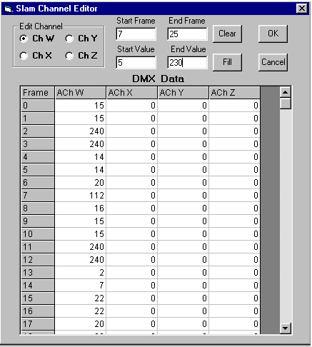

DMXEdit
The DMX Program is not intended for use with the MS-II but may be used to edit control files created with the Programmer or from onboard capture commands.

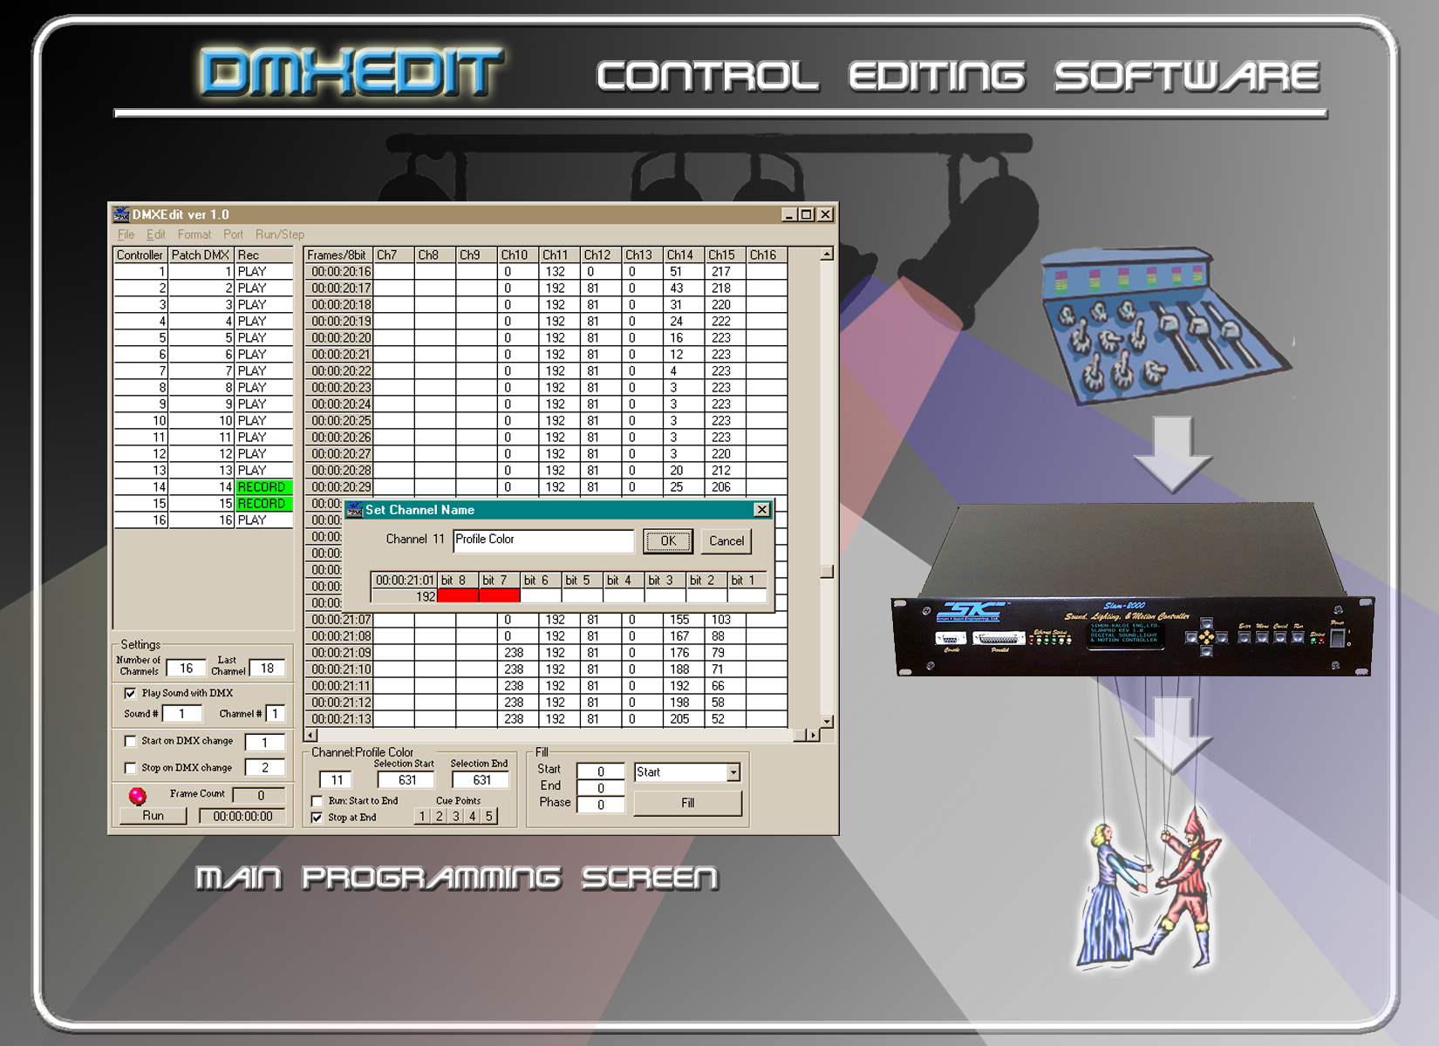

Loading a New Operating System

The Mini-SAM II has the ability to change its operating program. This is a useful feature as upgrades and enhancements become available. Upgrades are loaded using the “Install” command and connecting to the MS-2E with computer via the serial (and later Ethernet) port. A terminal program for the computer such as Hyperterminal should be used and you may also need a high-speed (capable of 115kb/s) USB to RS-232 adaptor. You must have the appropriate “*ms3eXXXX.ldr” file from SKE (can be download from the Software and Support Section of the www.skeng.com website) copied onto the CF card installed in the MS-2E.

IMPORTANT: The MS-2E Rev. 1.2 cannot accept older ms2XXXX.ldr or ms2eXXXX.ldr files. Loading incorrect files can render the MS-2E into a improper or non-functioning state and the only way to recover is the backup boot mode (Method 2). Scripts should not be running when performing and Install. To prevent the script from running you need to either temporarily remove any file named Startup.seq or change the name to something like Startup.txt or Test.seq. If you don’t want to modify the Startup file, you can power up the MS-2E without the CF card installed, then after the MS-2E completely boots and the CF card light flashes, install the CF card.

Method 1 (Normal Install): Power up the MS-2E. Once you see verify that the Boot code has loaded (it will look on the terminal just like the normal startup screen with BOOT in the message headers), move the BOOT switch back to normal (right) and perform the Install command as in Method 1. place an “.ldr” file on the CF card and install the card into the MS-2E. With a terminal program connected to the Console port (and later via the Ethernet interface), type the following:

Install “os name” <Enter>

Example:
Install ms3eXXXX <Enter>

where “os name” is the version of code that is to be loaded. Do not type the .ldr extension for the file. The status of the load will be displayed on the terminal program. After the load is complete, hit the RESET switch or repower the MS-2E and you should she on the terminal program that the new software is now installed.

Method 2 (Backup Install): In the rare case where the normal mode for loading was compromised e.g., due to a power fail during the process, you can use the backup install procedure. To do this, move the BOOT switch to the left and boot up the MS-2E while monitor with a terminal program as in Method 1. Make sure that the correct version of OS has been copied onto the CF Card. Once you see verify that the Boot code has loaded (it will look on the terminal just like the normal startup screen with BOOT in the message headers), move the BOOT switch back to normal (right) and perform the Install command as in Method 1. place an “.ldr” file on the CF card and install the card into the MS-2E. With a terminal program connected to the Console port (and later via the Ethernet interface), type the following:

Install “os name” <Enter>

Example:
Install ms3eXXXX <Enter>

where “os name” is the version of code that is to be loaded. Do not type the .ldr extension for the file. The status of the load will be displayed on the terminal program. After the load is complete, hit the RESET switch or repower the MS-2E and you should she on the terminal program that the new software is now installed.

Features and Specifications

- 2.1 stereo or two mono audio outputs. Multi-channel polyphony feature.
- 16 to 24-bit (capable with future OS) PCM Audio. Up to 48.1 Khz sampling. Maximum number of messages limited only by CF card size.
- Embedded digital signal processing (DSP) including seven-band EQ, compression/expansion, subwoofer crossover,
- Ducking, cross-fading, independent track and channel volume controls.
- On-board two-channel power amplifier. 80W x 80W into 4 ohms, 40W x 40W into 8 ohms (4 ohms or greater recommended speaker impedance).
- Audio line outputs, provisions for audio line and microphone inputs with on-board analog to digital converters.
- Compact Flash Interface (CF cards sold separately).
- 16 discrete bits of digital output control, low-side switching via open-collector transistors 125mA typical. Option for high-side control.
- 8 optically isolated input triggers with high optional or low-side triggering standard.
- RS-232/RS-485 interfaces allow programming, triggering and additional control. DMX-512 in and out for control expansion.
- Powerful Sequence Programming language and emulation for user scripting of event triggering, programming, scripting, and diagnostics.
- 2.1 audio, output control, DMX-512, audio channel and track volume and ducking, and many other functions.
- On-board real-time clock with backup battery. Real-time event triggering through sequence programming.
- Operating system can be upgraded in the field.
- Ethernet Interface.
- Recommended Power Supply: 12-26 Volts DC @ 3 Amps (5 Amps Max).
- Compact Enclosure; 5.125” L x 5.125” W x 1.5” D. Weight 1 lb. 2 oz. Several possible mounting configurations. One year warranty.

Specifications and appearance are subject to change without notice.

Chassis Mounting Diagram

WARRANTY
Simon-Kaloi Engineering, Ltd. ("SKE"), warrants this product to be free from defects for a period of one year from the date of purchase. If this product is defective under warranty, it must be returned to SKE or authorized service representative with proof of purchase (shipping costs for service are not covered by the warranty). This warranty is in lieu of all other warranties, expressed or implied, including, but not limited to, the implied warranties of merchantability or fitness for particular purpose, which are hereby expressly disclaimed. Warranty service must be performed by SKE or by SKE authorized service representative. Unauthorized service invalidates the warranty.

LIMITATION OF LIABILITY
SKE shall not be liable for any damage due to accident, abuse, misuse, normal wear and tear, or exceeding manufacturer’s specifications. The only remedy for breach of warranty is repair or replacement at the sole discretion of SKE. SKE shall not be liable for any incidental or consequential damages for breach of any expressed or implied warranty. SKE shall not be liable for any damage, whether arising in tort, contract or otherwise, for any amount in excess of the dealer cost of the product. Any claims for breach of warranty or contract must be brought within one year of acceptance of the product. Notice of such claims must be received by SKE within 60 days after acceptance of the product.

All of the information in this document is believed to be accurate at the time of print however due to the dynamic nature of this product, all features, specifications, and other information are subject to change without notice.

31192 La Baya Drive Unit G • Westalke Village, CA 91362
Phone: (818) 707-8400 • Fax: (818) 707-8401
Website: email: sales@skeng.com

